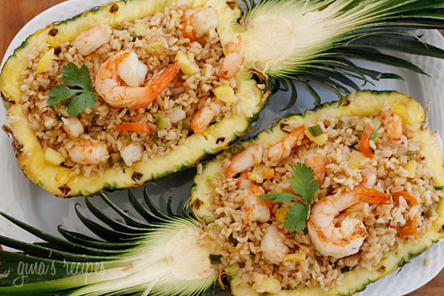

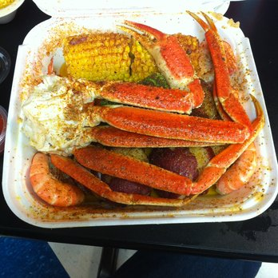

“Don’t trip we’ve got you covered”

Trippy Chef wants to give everyone an opportunity to enjoy high quality food at a low price. No matter what your budget is Trippy chef can work with you to create a menu for any event. Life is too short for bad food!

http://www.cityautorental.net/wp-content/images/payments-accepted.jpg

Follow us on Instagram



@TrippyChef

Follow us on SnapChat



@TrippyChef

SHOUT OUTS GET YOU FREE FOOD!

*Follow us to find out*

# unnamed.png

#### KITCHEN HOURS

#### Friday 10pm-3am

**Saturday 10pm-3am**

**Sunday 5pm-12am**

**PICK UP & ON CAMPUS DELIVERY**

*CALL, TEXT, OR EMAIL YOUR ORDER*

Outside menu background

Inside menu background

|  |  |
| --- | --- |
| Dessert | |
|  | |
| The Trippy Chef FUNNEL CAKE | $6.00 |
| It’s Granny’s Recipe.  A classic funnel cake with a trippy chef twist.  *Add strawberry & whip cream for $1.00*  *Add vanilla ice cream for $1.00*  CAN YOU GUESS WHAT MAKES OUR FUNNEL CAKES SO TRIPPY? | |
| Image result for mystery | |

|  |  |
| --- | --- |
| Plates *Were not your mom!*  *Create your own plate and pick your sides!*   1. Pick one | |
| (all plates come with garlic bread & drink) | |
| Meal of the Day! | $10.00 |
| From Kobe burgers topped with lobster to chicken tacos, it’s what we feel like cooking that day! Call & ask! | |
| Crab Legs | $15.00 |
| Fresh, steamed and seasoned lightly with our secret herb blend butter  Shrimp $8.00 | |
| Big juicy shrimp seasoned & grilled to perfection! |  |
| 1. Pick 2 sides*extra | |
| Mac & cheese  Green beans  White rice/Fried rice  Sweet potatoes  Corn on the cob Munchies | |
| The perfect late night meal | |
| The Trippy Mac & Cheese Burger | $5.00 |
| One beef patty with leaf lettuce, onion & tomato topped with our delicious Mac & cheese on a toasted garlic herb bun!  *Veggie patty-$1.00* | |
| The Trippy Mac & cheese Hotdog | $5.00 |
| 100% beef hot dog topped with Mac & cheese & a drizzle of ketchup. | |
| Pineapple boats | $8.00 |
| One pineapple cut in half stuffed with your choice of white or fried rice.  *Add chicken for $1.00*  *Add shrimp for $2.00*  *Add crab for $3.00* | |

|  |  |
| --- | --- |
| Catering Services *15 people minimum* | |
| **Step 1. Pick Your Style of Dinner** | |
| Standard Dinners | **\*$9.00** |
| Great for Parties, Graduations, & other non- formal events.  *This services includes delivery only* | |
| Luxury Dinners | **\*$17.00** |
| Great for weddings and formal events.  *This service includes delivery, set up & tear down.*  (Call for questions) | |
|  |
| ***Step 2. Pick your course*** | |
| Standard Courses   * Bacon wrapped sirloin * BBQ meat Balls * Baked chicken * Mac & Cheese Burger & Hot Dog Station * Pineapple Boats w/ Chicken | |
| Luxury Courses  * Lobster * (add $10.00 per person) * Snow Crab Legs * Rib eye Steaks*(add $2.00 per person) * Grilled stuffed Chicken * Tilapia * Pineapple boats w/ lobster &shrimp   ***Step 3. Pick your sides***  Standard Sides  (1 side included)   * Seasoned Green Beans * Fresh Corn on the Cob * Mac & Cheese * Mash Potatoes * Sweet Potato Mash * French fries   Luxury Sides  $2.00(per person)   * Lobster Mac & Cheese * Grilled Asparagus wrapped in bacon * Risotto * Sautéed Zucchini & Seasonal Veggies | |

Drinks- Sprite, Pepsi & water $1.00